Data Specification: Horizon Education Learning Access System
1. Scenario Overview
My proposal focuses on Horizon Education (HE), a non-profit organisation that provides educational support programs to disadvantaged students through tutoring, mentoring, and digital learning resources.
HE operates across multiple communities and coordinates volunteers, teachers, and students through structured learning activities, the system I am proposing is a Learning Access and Progress Monitoring System that will help manage these students, tutors, and learning sessions.
2. Real-World Challenge
Many students from disadvantaged backgrounds lack access to consistent academic support, this can negatively impact their education. Current approaches may rely on spreadsheets or manual records, making it harder to monitor attendance, evaluate program effectiveness.
The centralised system which I am proposing would improve how data is collected, stored, and reported, making managing student participation more efficient.
3. SDG Alignment
This system will support the United Nations Sustainable Development Goal number 4, which aims to ensure inclusive and equitable access to quality education.
By tracking student engagement, the system helps Horizon Education monitor the impact of its programs and identify where additional support is needed. This, in-turn, improving access to quality learning opportunities for these disadvantaged students.
4. Proposed System and Key Users
The proposed system will store and manage information about students, tutors, programs, learning sessions, and progress reports.
Key Users – Program Coordinators and Tutors
Program Coordinators
- Manage programs and learning sessions
- Assign tutors and monitor student participation
- Review attendance and progress reports
Tutors / Volunteers
- Record attendance for sessions
- Submit feedback or progress updates for students
- View assigned students and sessions

5. Data Sources and Evidence Base
My design was informed by datasets and reports from organisations such as UNESCO and the UK Department for Education. These sources publish data on educational participation, attainment levels, and inequalities in access to learning.
Common data elements in these sources include student demographics, attendance records, and academic performance indicators. The inclusion of entities such as students, sessions, attendance, and progress reports reflect common structures used in education monitoring systems.
6. Entity Relationship Diagram (1=One, M=Many)
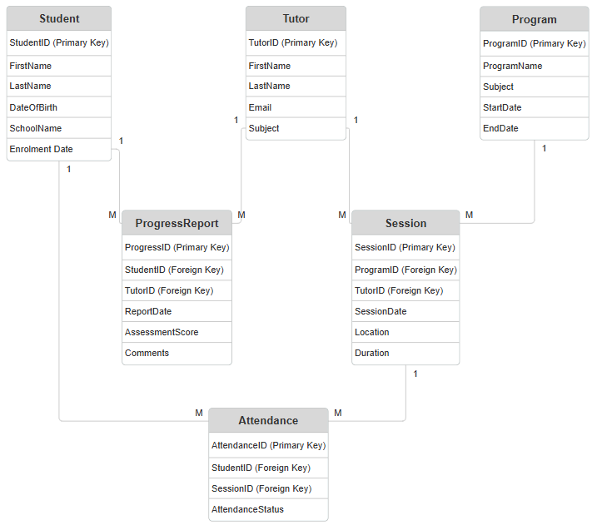

7. CRUD Functionality
The system must support the following core operations.
Create
Update
- Update student or tutor details
- Modify session schedules
- Edit attendance records
- Update progress report information
- Add new students to the system
- Register tutors or volunteers
- Create new programs and sessions
- Record attendance for learning sessions
- Submit progress reports for students
Delete
- Remove cancelled sessions
- Remove inactive tutor profiles
- Archive completed programs
8. Data Integrity and Security Constraints
Data Integrity Constraints
Examples of expected constraints include:
- NOT NULL for important fields such as student name, session date, and program name
- UNIQUE constraints for tutor email addresses and student identifiers
- Default values, such as setting attendance status to “Absent” unless recorded otherwise
- Validation rules, such as limiting assessment scores to a defined range (e.g., 0–100)
Security Considerations
Because the system stores student information, appropriate security controls are required. These may include:
- Role-based access control

- Secure login authentication

- Restricted editing permissions for sensitive data

